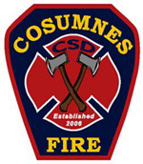
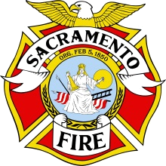


SOG Evaluation Form

AGENCY CONTACT

Cosumnes Fire Department B/C Kris Hubbard

Folsom Fire Department Captain Clint Madden

Sacramento Fire Department B/C Rick Hudson

Sacramento Metro Fire District A/C Chris Quinn

Please submit this form via e-mail to your agency contact listed above

Date of Incident: Dispatch Time:

Incident Number: SRFCC

Internal

Comments:

Submitted by: Station Shift
SROG Review Use

CAD After Action Report

Dispatch Audio CFIRS

SROG Follow-up Date

- CAD Documents SROG Review __________

- Dispatch Audio Agency Review __________

- After Action Report County Ops Chiefs Review __________

- CFIRS Review Closed __________

Reference page (If needed)

